# Instruction how to convert documents from the .docx format to the MediaWiki mark-up using docx2wiki converter

Summary

Instruction how to convert documents from the .docx format to the MediaWiki mark-up MediaWiki 1

Install PowerShell 1

How to use docx2wiki convert tool 1

Creating of the new wiki page after docx. file converting 3

Additional remarks 4

## Install PowerShell

1. Download PowerShell to the Wiki server and install the PowerShell toolset

https://technet.microsoft.com/ru-ru/library/hh847837.aspx#BKMK_InstallingOnWindows8andWindowsServer2012

## How to use docx2wiki convert tool

1. Download docx2wiki project from the GitHub.
2. Create the directory “C:\wiki\Convert” on the wiki server and unzip files from the GitHub zip project archive to the “C:\wiki\Convert” directory

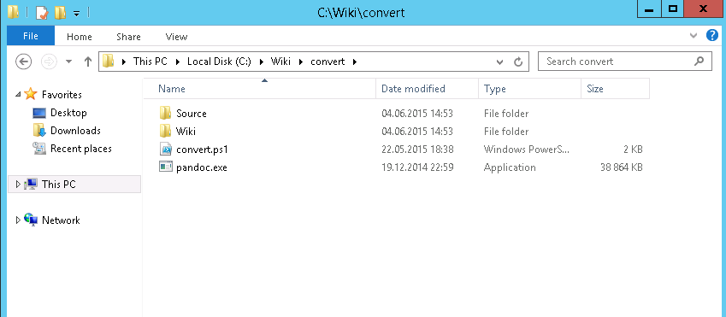

1. The “Convert” directory contains the next elements:

|  |  |
| --- | --- |
| **Element** | **Prescription** |
| convert.ps1 | PowerShell script performing convert work from .docx documents to the MediaWiki mark-up |
| Pandoc.exe | Open Source application for documents convert, downloaded from <http://pandoc.org/installing.html> |
| Source | Directory for the original .docx documents, which must be converted to the wiki mark-up |
| Wiki | Directory which contains images and wiki mark-up for the converted .docx documents as results of the convert process |

1. Copy original .docx documents to the “C:\Wiki\convert\Source” directory

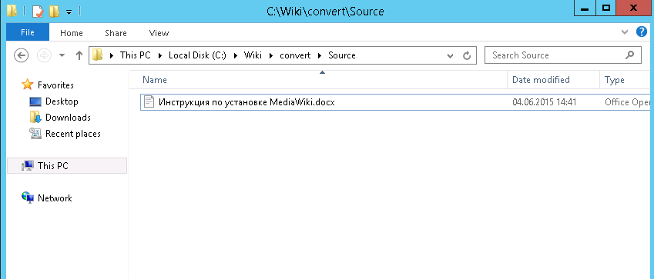

1. Open PowerShell, go to the “C:\wiki\convert” directory and run the next command

.\convert.ps1

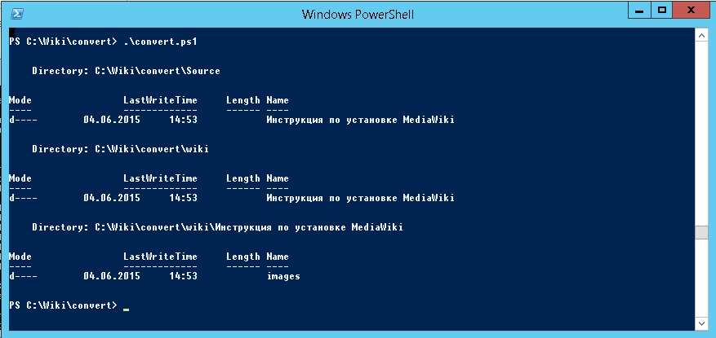

1. When the script will finish the convert work go to “C:\Wiki\convert\Wiki\” directory and then go to the directory with converted file name “C:\Wiki\convert\Wiki\docx_filename”
2. Check that “Images” directory and “ready_docx_filename .txt” file exist in the “docx_filename” directory

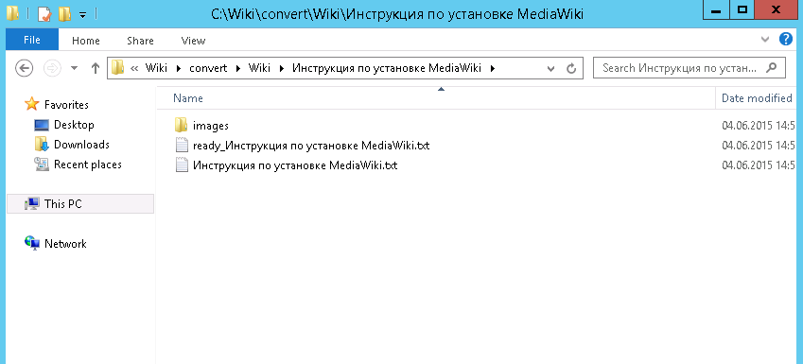

1. Open “ready_docx_filename.txt” file in a text editor and check that wiki mark-up contains the links to the images. Pay attention that convert tool generates the unique image file name for every image.

## Creating a new wiki page after docx. file converting

1. Go to the new wiki page edit screen

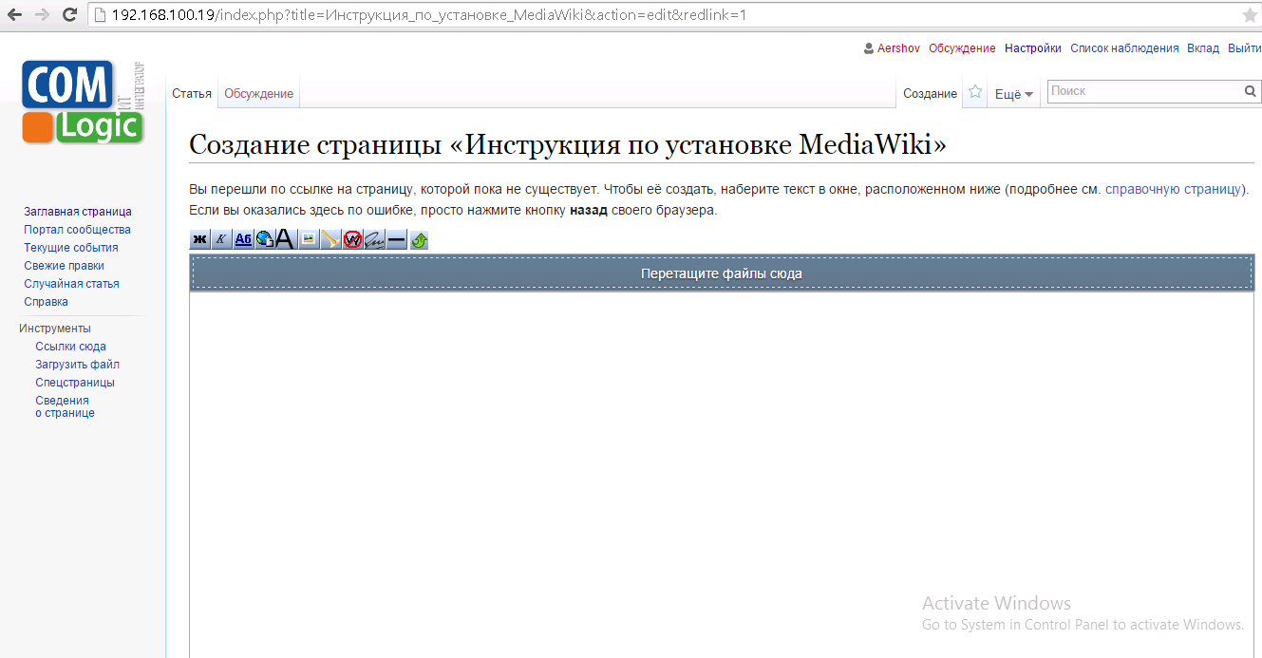

1. Copy the content of the “ready_docx_filename.txt” file to the wiki editor
2. Drag-and-drop all images from the “images” directory to the upload files field (this function will be available after installation of the “MsUpload” extension) and upload all dropped files to the wiki

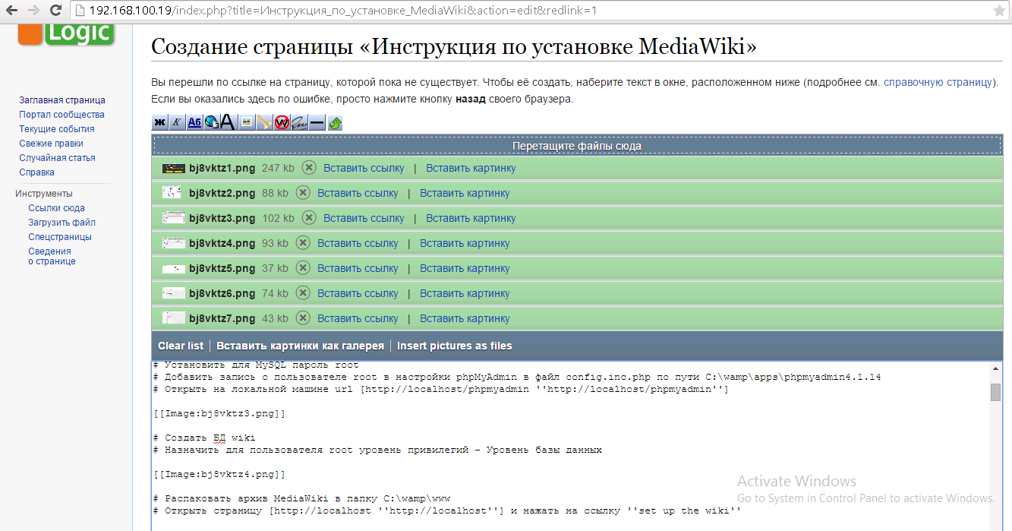

1. Add additional tags to the wiki mark-up, like <pre> for the pre-formatted text
2. Click the button “Write the page”
3. Check the content and images on the new Wiki page

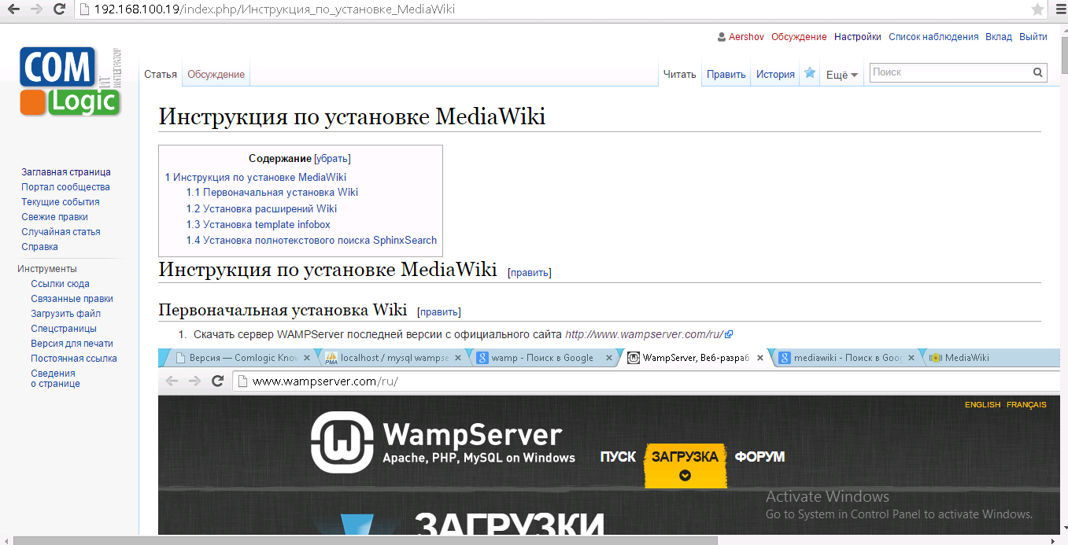

## Additional remarks

1. If a document has been converted without images, open the original .docx document in the Word application, save it in the .docx format and try to perform converting process again.
2. If you want to convert PDF file to the Wiki mark-up, try to convert it to the .docx format first, for example with the help of this tool <http://convertonlinefree.com/PDFToWORDEN.aspx>
3. If you have a big amount of images, you can use this php tool for transferring them to the wiki <http://www.mediawiki.org/wiki/Manual:ImportImages.php>

For example, for transferring the images in the example above you need to oped command line, go to the “C:\wamp\bin\php\php5.5.12” directory and run the next command:

Php.exe C:\wamp\www\maintenance\importImages.php “C:\Wiki\convert\Wiki\docx_file_name\Images” png jpg

